**NAME……………………………………….…………… INDEX NO……………………**

**SCHOOL…………………………………SIGNATURE……………… DATE…………..**

**451/1**

**COMPUTER STUDIES PAPER 1**

**(THEORY)**

**FORM 3**

**TERM 1, MARCH/APRIL 2025**

**TIME: 2 ½ HOURS**

**Instructions to Candidates**

1. Write your name and admission number in the spaces provided above.
2. This Paper consists of two sections **A** and **B**.
3. Answer **ALL** the questions in section **A**.
4. Answer ***question 16 (compulsory)*** and **any other** ***three*** questions from section **B.**
5. **All** answers should be written in the spaces provided.
6. This paper consists of **12 printed pages**. Candidates should check to ensure that all pages are printed as indicated and no questions are missing

**FOR EXAMINER’S USE ONLY**

|  |  |  |
| --- | --- | --- |
| **Section** | **Questions** | **Candidate’s score** |
| **A** | 1. **15** |  |
| **B** | **16** |  |
| **17** |  |
| **18** |  |
| **19** |  |
| **20** |  |
| **TOTAL SCORE** |  |

**SECTION A (40MARKS)**

***Answer all the questions in this section***

1. State **three** differences between impact printers and non-impact printer(3marks)
2. Define the following terms as used in mail merging (2 marks)
   1. Main document
   2. Data source
3. Peter used a compact disk recordable to save his work. ½ of the disk was used to store video files while ¼ of the remainder was to save audio file. Note that CD-recordable is 700MB. Calculate the remaining space in bytes (3marks)
4. Describe **four** ways in which ICT can be used to improve health care provision (4Marks)
5. State the functions of the following special purpose memories (3marks)
6. Buffers
7. Cache
8. Registers
9. Describe the term portability as used in the following context.  
   i. **Hardware** (1mark)

ii. **Software** (1mark)

1. John is a first-year student at JKUAT. He is expected to login his student portal to access online assignments. Mention three ways in which he would prevent virus from infecting his computer (3marks)
2. Using relevant examples distinguish between a formula and function (2marks)
3. Musato high school wanted to setup a network connectivity to be used in school. Mention three internet connectivity requirement that the school must have in order to get the connection (3marks)
   * 1. A world wide web is a vast virtual space where information is made available such web portals and blogs. Differentiate between a web portal and a blog.(2mks)
4. State the function of the following keys.  
   i. **Return key**(1mark)

ii. **Delete** (1mark)

1. Describe the following features of Database management software.  
   i. **Macro** (1mark)

ii. **Table** (1mark)

1. State **three** examples of microcomputers (3marks)
2. Milenga Special School received grants from the National government to purchase computers to be used in the departments and the Headteachers’ office, as a computer student, the headteacher approached you to guide him on the hardware and software considerations to execute the project. Mention four hardware related factors that you need to consider for the project to be implemented successful (4marks)
3. Describe three functions of an operating system(3marks)
4. Describe the effects of the following actions in a computer lab.  
   a. Eating in a computer laboratory (1mark)

b. Smoking in the computer laboratory (1mark)

**SECTION B (60 MARKS)**

*Answer Question 16 and any other three questions in this section.*

i. Describe three components of a spreadsheet (3marks)

ii. State three advantages of electronic spreadsheets over manual spreadsheets (3marks)

iii. A School keeps a spreadsheet of examination results in four subjects. Part of the spreadsheet is shown below.

|  |  |  |  |  |  |  |  |  |
| --- | --- | --- | --- | --- | --- | --- | --- | --- |
| **A** | **B** | **C** | **D** | **E** | **F** | **G** | **H** | **I** |
| 1 | Name | Class | Math | Science | IT | English | Average | Position |
| 2 | Peruza | 11C | 87 | 72 | 64 | 61 | 71 | 1 |
| 3 | Kegg | 11A | 82 | 69 | 57 | 52 | 65 | 2 |
| 4 | Kolacz | 11A | 73 | 51 | 73 | 51 | 62 | 3 |
| 5 | Khan | 11C | 44 | 21 | 50 | 85 | 50 | 4 |
| 6 | Dyos | 11B | 41 | 54 | 70 | 31 | 49 | 5 |
| 7 | Lenski | 11B | 17 | 41 | 40 | 34 | 33 | 6 |
| 8 | Allen | 11A | 33 | 24 | 19 | 44 | 30 | 7 |
| 9 | Mean score | - | 53.86 | 47.43 | 53.29 | 51.14 | 51.43 |  |
| 10 | Highest | 87 | Lowest | 17 | ######## |  |  |  |

**Table 1**

1. What formula has been used to:  
   i. Calculate the mean score for Math (1mark)

ii. Assign Lenski position 6 out of 7 (1mark)

iii. Get student with the highest marks in Math and Science (1mark)

1. Show how cell G10 can be represented in R1C1 style (1mark)
2. Write a function that will display Excellent, Good, Average and Fail in the remark column based on the average score (3marks)

|  |  |
| --- | --- |
| **Average** | **Remark** |
| 66 - 100 | Excellent |
| 46 - 65 | Good |
| 36 - 45 | Average |
| 0 - 35 | Fail |

d. State the validation check that should be carried out on data entered in cell C2 to F8 to ensure values over 100 are not input (2marks)

**17.**

1. Differentiate between insert and overtype editing modes (2 marks)
2. With an aid of a diagram explain the difference between merging cells and splitting cells (3marks)
3. Mark Jacob typed Kanga High School in a Ms-Word workspace. State how the line of text will appear if he applies the following change case option.
4. Toggle case (1mark)
5. Sentence case (1mark)
6. Upper case (1mark)
7. James was preparing a document which contains lines of text and graphic. When he typed the last sentence, the whole sentence was pushed to the next page making the document to have two pages. Mention four ways that can be applied to this document to make it fits with a page (3marks)
8. Describe four proofreading tools supported by MS Word (4marks)
9. Define word wrap as used in word processors (1 mark)

18. (a) The information in figure 3 below is maintained by the patron of wildlife club in a school. Study it and answer the questions that follow.  
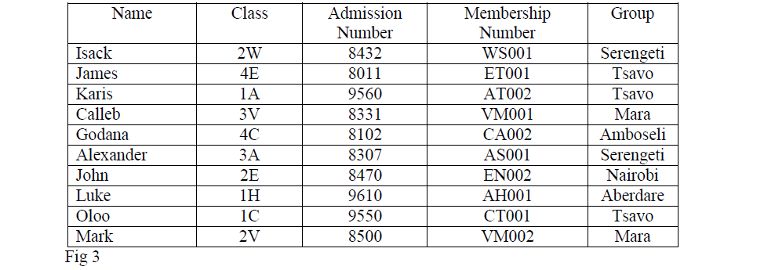  
(i) State the most appropriate primary key for the list. (1mk)

(ii)State the most appropriate data types for the fields (2mks)  
 (a) Admission number

(b) Membership number.

(iii) If a database was to be created for the list; forms, tables, queries and reports are likely to be used. State the purpose of each of these objects. (2mks)

(iv) How many field values are in the list? (1mk)

(v) How many records are in the list? (1mk)

(b) A trader uses a spreadsheet program to calculate profits.  
The figure below shows the spreadsheet.

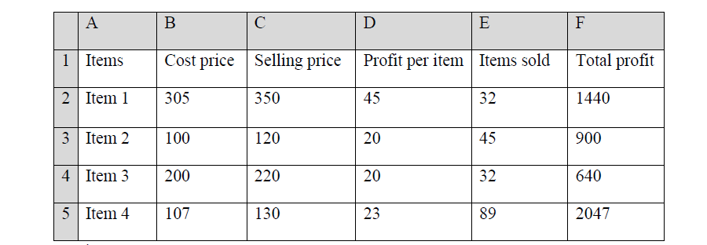

(i) Which row contains labels only? (1mk)

(ii) Write the formula that has been entered in cell F2. (2mks)

(c)State three features of fifth generation computers. (3mks)

(d) Differentiate between DVD RW and CD R. (2mks)

19. a) Workout the equivalent of the following numbers

i) 113.2510 = X2 (3marks)

ii) 1001110.100112 = X10  (3marks)

b) Workout using two’s complements

i) 5710 – 2910  (3marks)

ii) 110012 + (-1111012) (3marks)

iii) Find the BCD equivalent of 3710 (2marks)

1. a) Which key on the keyboard can play the role of the start button? (1mark)
2. Give **two** uses of the task manager. (2marks)
3. One characteristics of an operating system is to control computer. State **two** resources under the operating system control. (2marks)
4. State and explain the three core principles of data security. (6 marks)
5. State any four measures that can be observed to protect an information system against malware. (4marks)
6. Give two examples of operating systems used in smartphones. (1mark)